1. Create an html page to display the following nested list

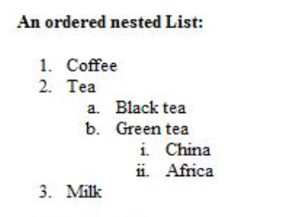

**Codes:**

<html>

<head><title>nested list</title></head>

<body style="font-size: 11px;">

<br>

<br>

<br>

<p><b>An ordered nested list:</p>

<ol>

<li>Coffee</li>

<li>Tea</li>

<ol type="a">

<li>Black tea</li>

<li>Green tea</li>

</ol>

<ol type="i">

<li>China</li>

<li>Africa</li>

</ol>

<li>Milk</li>

</ol>

</b>

</body>

</html>

**Output window:**

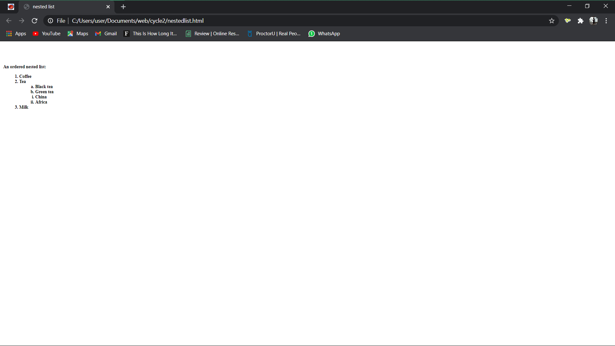

1. Create links to three different pages on three different websites that should all open in a new window.

**Codes:**

<html>

<head><title>three webpages</title></head>

<body>

<br>

<br>

<br>

<CENTER>

<h1><b><u>Link to three webpages on three different websites</u></b></h1>

<br><br>

<a href="https://wikipedia.com" target="_blank">wikipedia homepage</a>

<br><br>

<a href="https://github.com" target="_blank">github homepage</a>

<br>

<br>

<a href="https://wordpress.com" target="_blank">wordpress homepage</a>

</CENTER>

</body>

</html>

**Output window:**

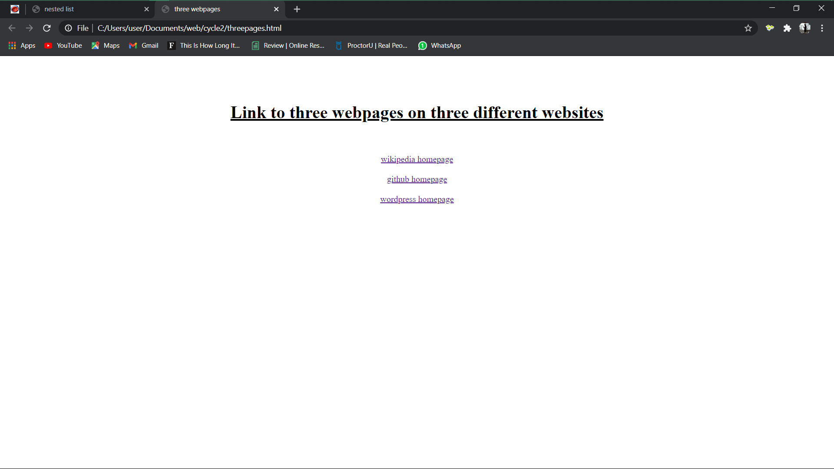

1. Create a page with a link at the top of it that when clicked will jump all the way to the bottom of the page.

**Codes:**

<html>

<head><title>LINK TO BOTTOM</title></head>

<body style="font-size: 16px;">

<br>

<br>

<br>

<center>

<a name="top">

<a href="#bottom">click here to go bottom</a>

<br>

<p align="CENTER"><b>the link given above can be used to move the position of the current window to the bottom.to feel, just simply click the <u>click here</u></p>

<br>

<br>

<br>

<br>

<br>

<br>

<br>

<br>

<br>

<br>

<br>

<br>

<br>

<br>

<br>

<br>

<br>

<br>

<br>

<br>

<br>

<br>

<br>

<br>

<br>

<br>

<br>

<br>

<br>

<br>

<br>

<br>

<br>

<br>

<br>

<br>

<br>

<br>

<br>

<br>

<br>

<br>

<br>

<br>

<br>

<br>

<br>

<br>

<br>

<br>

<br>

<br>

<br>

<br>

<br>

<br>

<br>

<br>

<br>

<br>

<br>

<br>

<br>

<br>

<br>

<br>

<br>

<br>

<br>

<br>

<br>

<br>

<br>

<br>

<br>

<br>

<br>

<br>

<br>

<br>

<br>

<br>

<br>

<br>

<br>

<br>

<br>

<br>

<br>

<br>

<br>

<br>

<br>

<br>

<br>

<br>

<br>

<br>

<br>

<br>

<br>

<a name="bottom">

<a href="#top" style="color:red;">click here to goback</a>

<br>

<br>

</center>

</b>

</body>

</html>

**Output window:**

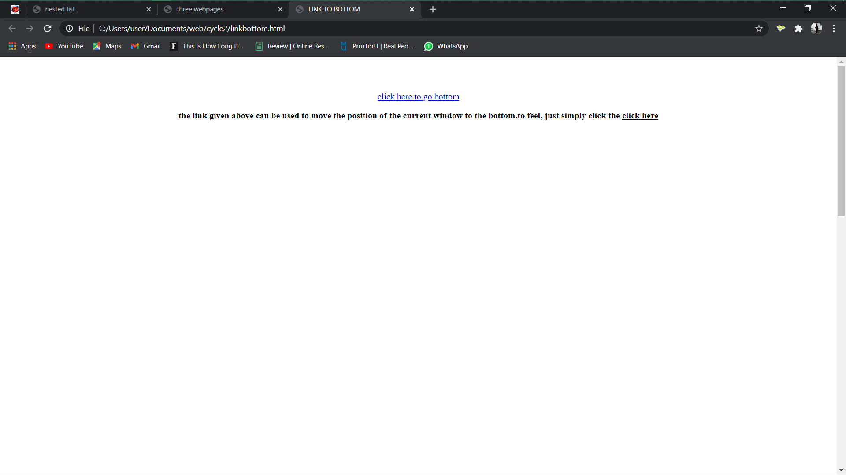

1. Display three different images. Skip two lines between each image. Each image should have a heading.

**Codes:**

<html>

<head><title>IMAGE and HEADINGS</title></head>

<body>

<br>

<br>

<br>

<CENTER>

<p><b><u>Images and Headings</u></b></p>

<h1>Image 1</h1>

<img src="C:\Users\user\Documents\web\cycle2\Screenshot_20200322-195428.png" width="200" height="250">

<br>

<br>

<h1>Image 2</h1>

<img src="C:\Users\user\Documents\web\cycle2\Screenshot_20200430-195920.png" width="200" height="250">

<br>

<br>

<h1>Image 3</h1>

<img src="

</CENTER>

</body>

</html>

**Output window:**

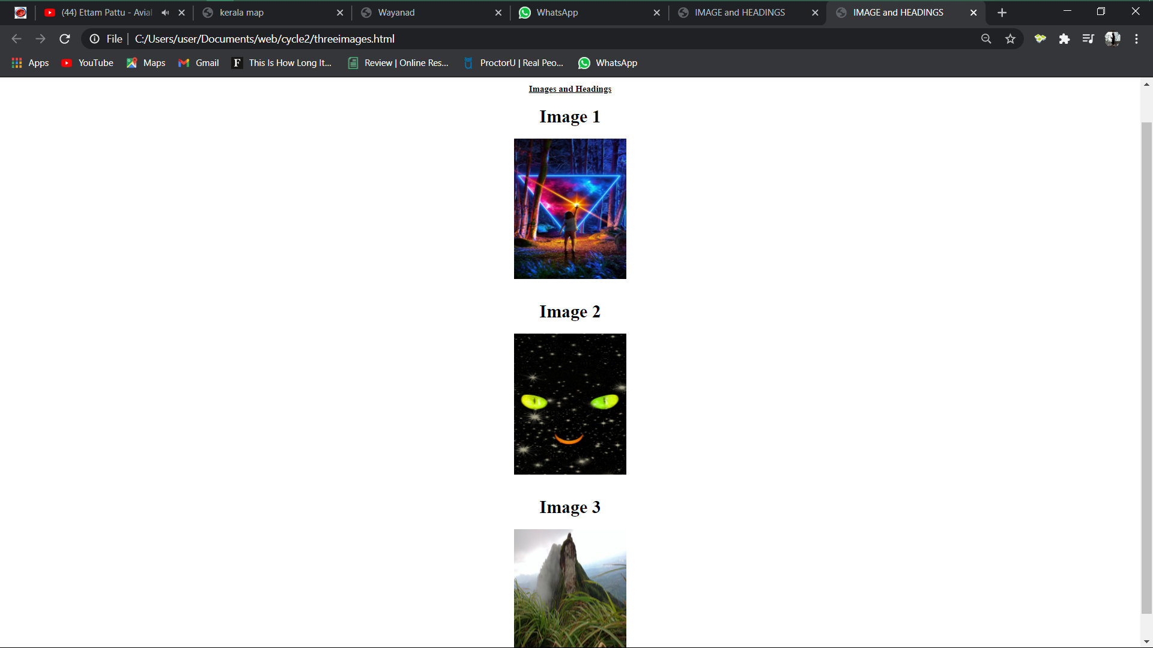

1. Display an image that when clicked will link to a search engine of your choice in a different window.

**Codes:**

<html>

<head><title>image search engine</title></head>

<body>

<br>

<br>

<br>

<CENTER>

<h1><b>click the duckduckgo.com logo to search.</b></h1>

<br>

<a href="https://duckduckgo.com" target="_blank"><img src="download.jpeg"><br>

</a>

</CENTER>

</body>

</html>

**Output window:**



1. Create the following Html Page using appropriate form controls.

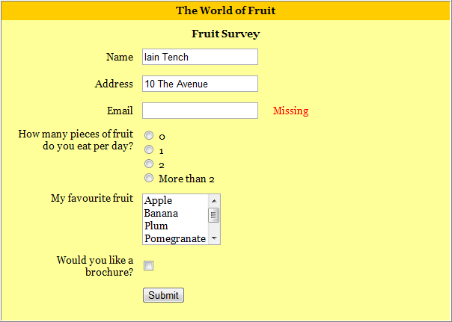

Codes:

**Main window**

<html>

<frameset rows="5%,*" border="0">

<frame src="fruit1.html"></frame>

<frame src="fruit2.html"></frame>

</frameset>

</html>

**Frame 1**

<html>

<head><title>fruit frame1</title>

</head>

<body bgcolor="orange">

<center>

<h3>The world of fruit</h3>

</center>

</body>

</html>

**Frame 2**

<html>

<head><title>fruit survey</title>

</head>

<body bgcolor="yellow">

<b>

<h3 align="center">Fruit Survey</h3>

<form>

<table align="center" cellspacing="4">

<tr>

<td>name </td>

<td>

<input type="text" placeholder="Iain Tench" name=" ">

</td>

</tr>

<tr>

<td>address</td>

<td>

<input type="text" placeholder="10 The Avenue" name=" ">

</td>

</tr>

<tr>

<td>email</td>

<td>

<input type="text" name=" ">

</td>

<td>

<font color="red">missing</font>

</td>

</tr>

<tr>

<td>how many peace of fruit</td>

<td>

<input type="radio" name=""> 0 </td>

</tr>

<tr>

<td>

do you eat per day?</td>

<td>

<input type="radio" name=""> 1

</td></tr>

<tr><td></td>

<td>

<input type="radio" name=""> 2 </td></tr>

<tr><td></td>

<td>

<input type="radio" name=""> more than 2

</td>

</tr>

<tr>

<td>

<label for="fruits">My favourite fruit:</label>

</td><td>

<select name="fruts" id="fruits">

<option value="apple">apple</option>

<option value="banana">banana</option>

<option value="plum">plum</option>

<option value="pomegranate">pomegranate</option>

</select>

</td></tr>

<tr>

<td>would you like a </td>

<td>

<input type="checkbox" name="">

</td>

</tr>

<tr><td>brochure?</td></tr>

<tr><td></td><td>

<input type="submit" value="submit">

</td>

</tr>

</table>

</form>

</b>

</body>

</html>

**Output window:**

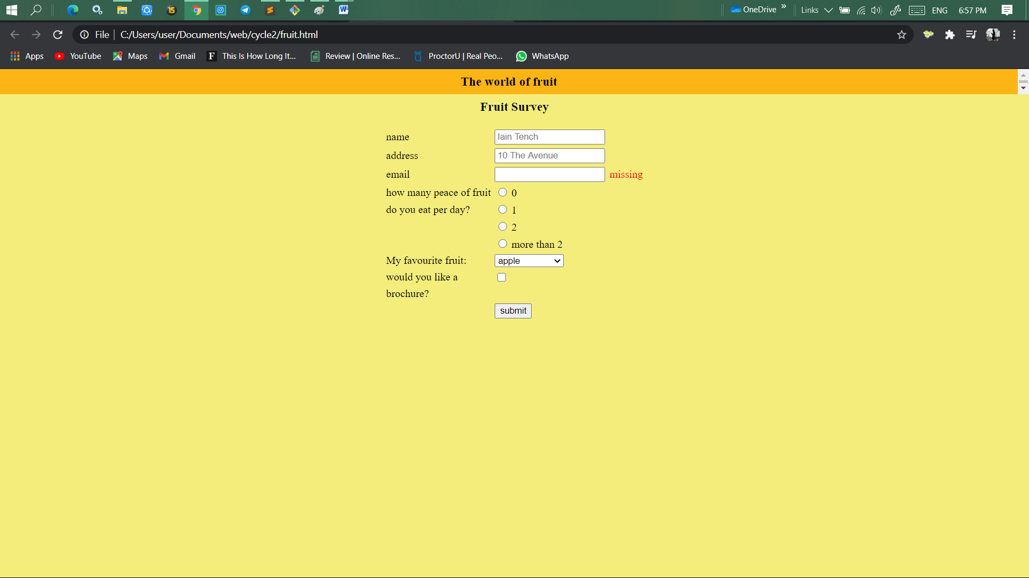

1. Create an image map for ‘Kerala Map’. Map at least 3 districts so that when you click on that particular district the details regarding that district(**eg: population, Area, Tourist Spots(with images), Monuments, Interesting Facts )** should be displayed on a new page.

**Codes:**

**Main window(kerala map):**

<html>

<head><title>kerala map</title></head>

<body>

<br>

<h1 align="center"><b><u>Kerala map</u></b></h1>

<map name="keralamap">

<area shape="rect" coords="697,1170,801,1246" href="kottayam.html" target="blank">

<area shape="rect" coords="498,429,623,487" href="wayanad.html" target="blank">

<area shape="rect" coords="821,1026,936,1171" href="idukki.html" target="blank">

</map>

<img src="keralamap.png" usemap="#keralamap">

</body>

</html>

**Codes (kottayam):**

<html>

<head><title>kottayam</title></head>

<body bgcolor="black">

<br>

<font color="white">

<h1 align="center"><b><u>Kottayam</u></b></h1>

<br>

<center>

<img src="Kottayam_Collage.jpg" align="center" width="300" height="300">

</center>

<p>

Kottayam (കോട്ടയം)is a city in the Indian state of Kerala.[1] Kottayam literally means the interior of a fort—Kotta + Akam.[2] Flanked by the Western Ghats on the east and the Vembanad Lake and paddy fields of Kuttanad on the west, Kottayam is a place that is known for extraordinary qualities.[3] It is the district headquarters of Kottayam district, located in south-west Kerala. Kottayam is located in the basin of the Meenachil River at an average elevation of 3 metres (9.8 ft) above sea level, and has a moderate climate. It is located 150 kilometres (93 mi) north of the state capital Thiruvananthapuram.

The city is known for its trade in natural rubber, and the national Rubber Board is headquartered in the city, as is the Plantation Corporation of Kerala. Kottayam Port is India's first multi-modal inland container depot. The headquarters of the Malankara Orthodox Syrian Church, called the Catholicate Aramana (Catholicate palace), is situated at nearby Devalokam.[not verified in body]

Many of the first Malayalam daily newspapers, like Deepika, Malayala Manorama, and Mangalam, were started and are headquartered in Kottayam, as are a number of publishing houses.

<br>

<br>

area: 2208 sq.km

<br>

population:1,974,551

</p>

<center>

<br>

tourist spots: Illickal Kallu

<br>

<br>

<img src="Kallu.jpg" width="150" height="150">

<br><br>

Vembanad

<br>

<img src="lake.jpg" width="150" height="150">

<br><br>

Kumarakom Bird Sanctuary<br>

<br>

<img src="bird.jpg" width="300" height="150">

</center>

</font>

</body>

</html>

**Codes (idukki):**

<html>

<head><title>IDUKKI</title></head>

<body bgcolor="black">

<br>

<font color="red">

<h1 align="center"><b><u>Idukki</u></b></h1>

<br><center>

<img src="kattappana.jpg">

</center>

<br>

<p>

Idukki (ഇടുക്കി)is a district in the Indian state of Kerala.[2] It was constituted on 26 January 1972, by splitting the district of Kottayam into two parts. Its division was earlier headquartered at Kottayam city, but moved to Painavu in June 1976. Idukki district lies amid the Western Ghats of Kerala.

Though it is regarded as the second-largest district in the region, it has the lowest population density among the other districts of Kerala,[3] the urban population being higher than the rural. Idukki is rich in forests and also known as the "Spice Garden of Kerala".

Till 1998, when Kuttampuzha was added to Ernakulam district, Idukki was the largest district in Kerala.

</p>

<br>

<br>

area: 4358 sq.km

<br>

population: 11.1 lakhs

</p>

<center>

<br>

tourist spots: Munnar

<br>

<br>

<img src="munnar.jpg" width="150" height="150">

<br><br>

Anamudi

<br>

<img src="anamudi.jpg" width="150" height="150">

<br><br>

Bison Valleyy<br>

<br>

<img src="bison.jpeg" width="300" height="150">

</center>

</font>

</body>

</html>

**Codes (wayanad):**

<html>

<head><title>Wayanad</title></head>

<body bgcolor="black">

<br>

<font color="yellow">

<h1 align="center"><b><u>Wayanad</u></b></h1>

<br><center>

<img src="wayanad.jpg" align="center">

</center>

<br>

<p>

Wayanad is an Indian district in the north-east of Kerala state with administrative headquarters at the municipality of Kalpetta. It is set high on the Western Ghats with altitudes ranging from 700 to 2100 meters.[5] The district was formed on 1 November 1980 as the 12th district in Kerala by carving out areas from Kozhikode and Kannur districts. About 885.92 sq.km of area of the district is under forest.[6] Wayanad has three municipal towns—Kalpetta, Mananthavady and Sulthan Bathery. There are many indigenous tribals in this area.[7][8] In 2006 the Ministry of Panchayati Raj named Wayanad one of the country's 250 most backward districts out of a total of 640.[9]

Wayanad district is bordered by Karnataka to north and north-east, Tamil Nadu to south-east, Malappuram to south, Kozhikode to south-west and Kannur to north-west.[10] Pulpally in Wayanad boasts of the only Lava- Kusha temple in Kerala and Vythiri has the only mirror temple in Kerala which is a Jain temple. The edicts and caves of Ambukuthi Mala and another evidence state that the place is as old as the beginning of the New Age Civilisation.

<br>

<br>

area: 2,132sq.km

<br>

population: 8.17 lakhs(2011)

</p>

<center>

<br>

tourist spots: edakkal caves

<br>

<br>

<img src="edakkal.jpg" width="150" height="150">

<br><br>

kuruvadweep

<br>

<br>

<img src="island.jpeg" width="150" height="150">

<br><br>

Banasura sagar dam

<br>

<br>

<img src="dam.jpeg" width="500" height="150">

</center>

</font>

</body>

</html>

**Output window:**

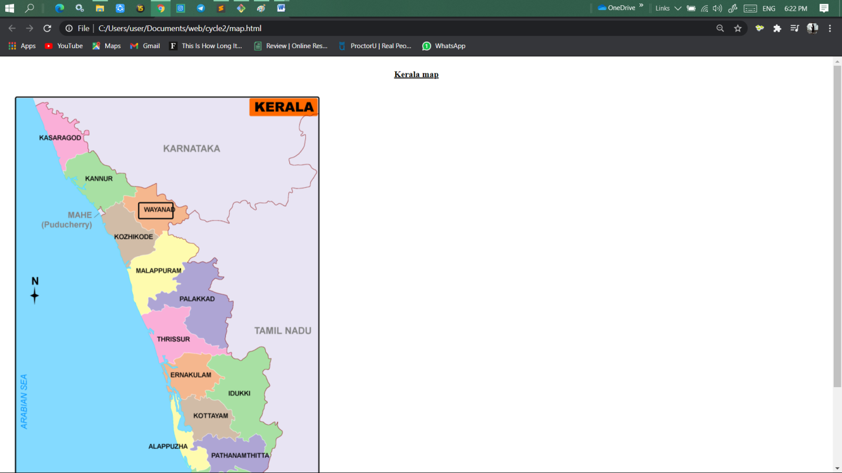

1. Construct this puzzle looking thing

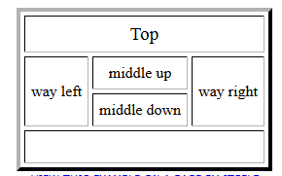

**Codes:**

<html>

<head><title>PUZZLE</title></head>

<body>

<br>

<br>

<br>

<CENTER>

<br>

<table border="4" cellspacing="4" cellpadding="5" width="280" height="200" >

<tr><th colspan="4">Top</th></tr>

<tr><td align="CENTER" style="font-size:14px;" rowspan="2"><b>way left</b></td>

<td align="CENTER" style="font-size:14px;"><b>middle up</b></td>

<td rowspan="2" align="CENTER" style="font-size:14px;"><b>way right</b></td>

</tr>

<tr>

<td align="CENTER" style="font-size:14px;"><b>middle down</b></td>

</tr>

<tr>

<td colspan="4"> </td>

</tr>

</table>

</CENTER>

</body>

</html>

**Output window:**

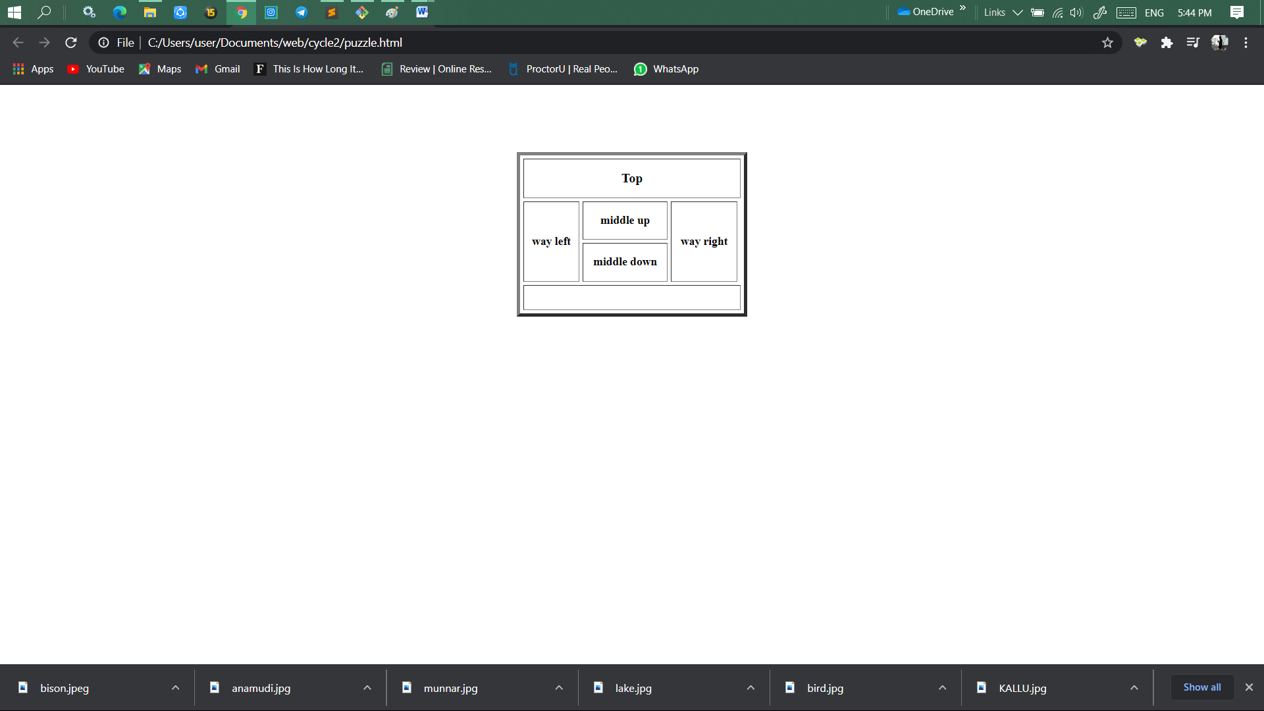

1. Make up three image links for 3 web browsers and put them in a borderless table. Construct the table so that there is just a little space between the images

**Codes:**

<html>

<head><title>image browsers</title></head>

<body>

<br>

<br>

<br>

<CENTER>

<p><b><u>click any of the below images to go to the specified browsers.</u></b></p>

<table>

<tr><td>

<a href="https://duckduckgo.com/chrome_newtab" target="_blank">

<img src="C:\Users\user\Documents\web\cycle2\download.jpeg" width="180" height="90">

</a>

</td></tr>

<tr>

<td>

<a href="https://bing.com" target="_blank"><img src="C:\Users\user\Documents\web\cycle2\bing.jpeg" width="180" height="90"></a>

</td>

</tr>

<tr>

<td>

<a href="https://yahoo.com" target="_blank"><img src="C:\Users\user\Documents\web\cycle2\yahoo.jpeg" width="180" height="90"></a>

</td>

</tr>

</table>

</CENTER>

</body>

</html>

**Output window:**

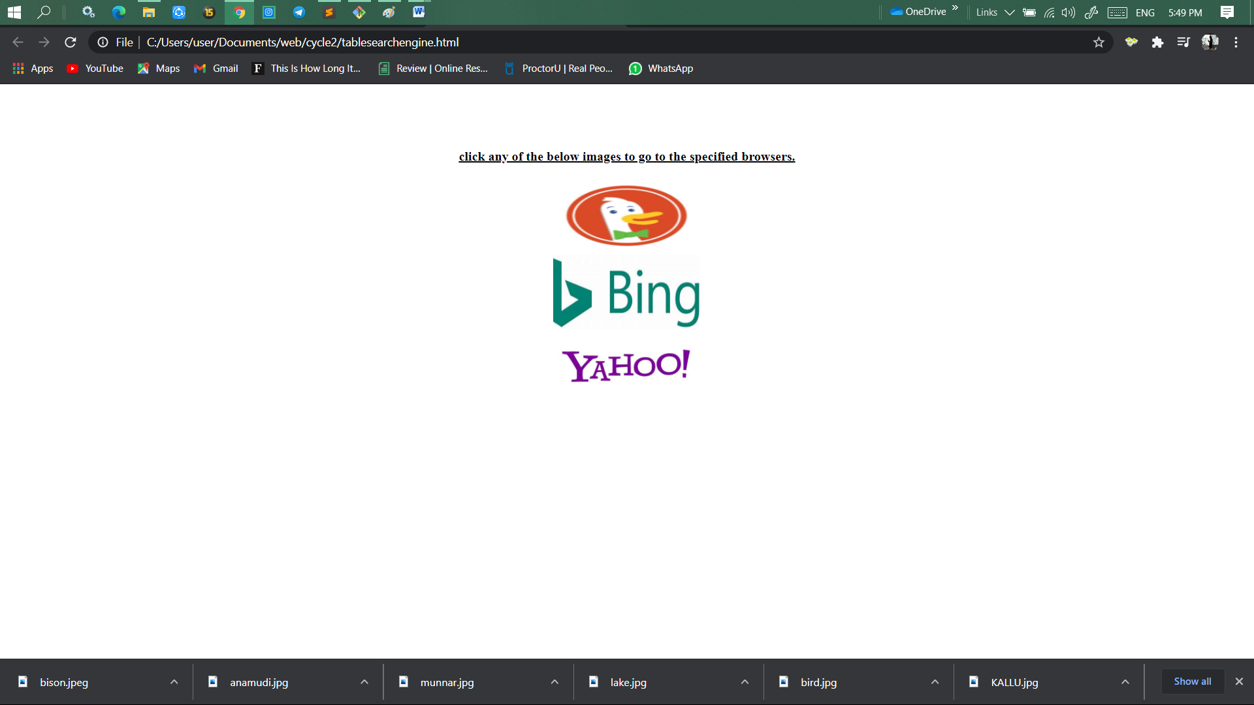

1. Create the following html page using frames

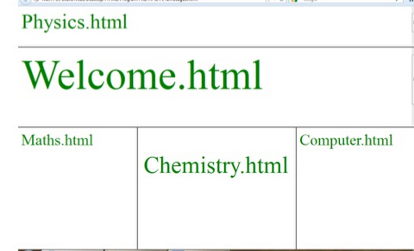

**Codes (main window):**

<html>

<frameset rows="20%,30%,*" border="3">

<frame src="physics.html">

<frame src="welcome.html">

<frame src="subjects.html">

</frameset>

</html>

**Codes (physics):**

<html>

<head><title>physics</title>

<style type="text/css">

p {

color: green;

font-size: 50px;

}

</style></head>

<body>

<p>Physics.html</p>>

</body>

</html>

**Codes (welcome):**

<html>

<head><title>welcome</title>

<style type="text/css">

h1 {

color: green;

font-size: 100px;

}

</style></head>

<body>

<h1>Welcome.html</h1>

</body>

</html>

**Codes (maths):**

<html>

<head><title>welcome</title>

<style type="text/css">

h1 {

color: green;

font-size: 100px;

}

</style></head>

<body>

<h1>Welcome.html</h1>

</body>

</html>

**Codes (chemistry):**

<html>

<head><title></title>

<style type="text/css">

p {

color: green;

font-size: 50px;

}

</style></head>

<body>

<br>

<br>

<p>Chemistry.html</p>

</body>

</html>

**Codes (computer):**

<html>

<head><title>computer</title>

<style type="text/css">

p {

color: green;

font-size: 40px;

}

</style></head>

<body>

<p>Computer.html</p>

</body>

</html>

**Output window:**

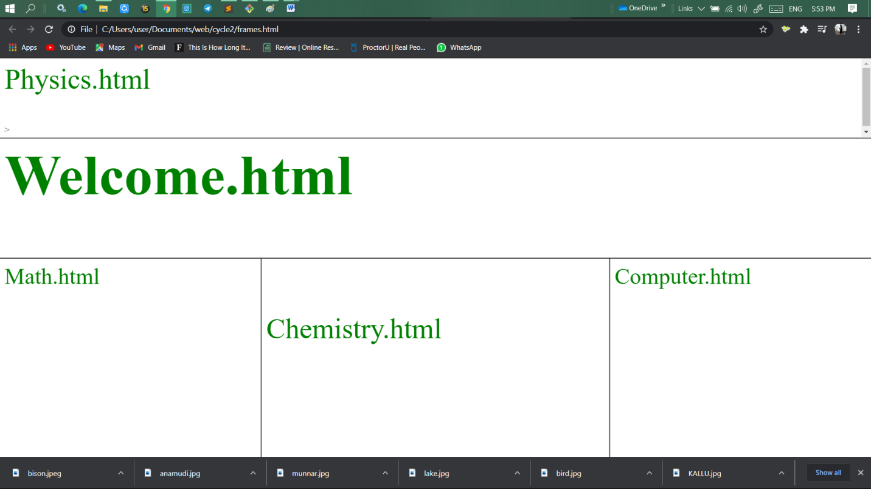

1. Create an HTML page using frames which is similar to the following one.

In the left frame provide hyperlinks to 3 important monuments in world. On clicking that hyperlink an image of the monument should be displayed in right frame with suitable description

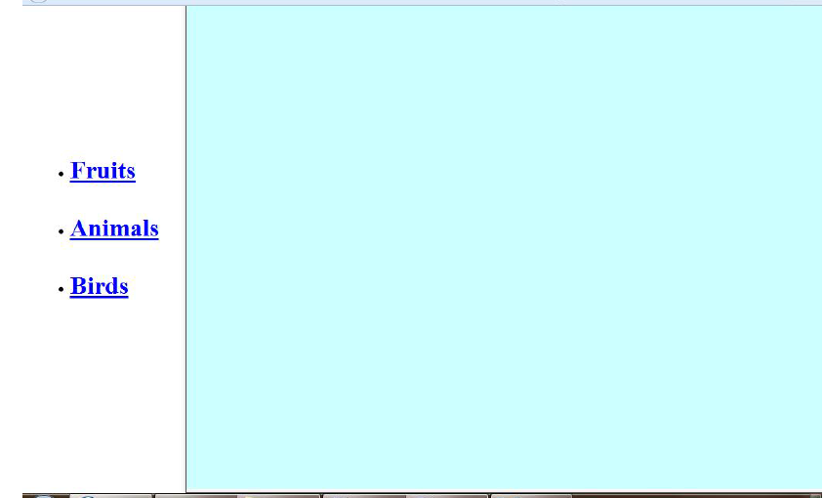

**Codes (main window):**

<html>

<frameset cols="15%,*" border="2">

<frame src="monument.html"></frame>

<frame src="respond.html" name="next"></frame>

</frameset>

</html>

**Codes ( left frame):**

<html>

<head><title>monument</title></head>

<body>

<center>

<br>

<br>

<br>

<br>

<br>

<br>

<br>

<br>

<b>

<a href="taj.html" target="next">Taj Mahal</a>

<br>

<br>

<a href="eiffel.html" target="next">Eiffel Tower</a>

<br>

<br>

<a href="qutabminar.html" target="next">Qutab Minar</a>

</b>

</center>

</body>

</html>

**Codes ( right frame):**

<html>

<head><title>respond frame</title></head>

<body bgcolor="aqua">

</body>

</html>

**Codes ( The Taj Mahal):**

<html>

<head><title>Taj Mahal</title></head>

<body>

<br>

<center>

<br>

<h1><b><u>The Taj Mahal</u></b></h1>

<br>

<img src="tajmahal.jpg">

<br>

<p>

The Taj Mahal is an ivory-white marble mausoleum on the southern bank of the river Yamuna in the Indian city of Agra. It was commissioned in 1632 by the Mughal emperor Shah Jahan (reigned from 1628 to 1658) to house the tomb of his favourite wife, Mumtaz Mahal; it also houses the tomb of Shah Jahan himself. The tomb is the centrepiece of a 17-hectare (42-acre) complex, which includes a mosque and a guest house, and is set in formal gardens bounded on three sides by a crenellated wall.

</p>

</center>

</body>

</html>

**Codes (The Eiffel Tower):**

<html>

<head><title>Eiffel Tower</title></head>

<body>

<br>

<center>

<h1><b><u>The Eiffel Tower</u></b></h1>

<br>

<img src="tower.jpg" height="300" width="200">

<br>

<p>

The Eiffel Tower is a wrought-iron lattice tower on the Champ de Mars in Paris, France. It is named after the engineer Gustave Eiffel, whose company designed and built the tower.

Locally nicknamed "La dame de fer" (English for "Iron Lady"), it was constructed from 1887 to 1889 as the entrance to the 1889 World's Fair, it was initially criticised by some of France's leading artists and intellectuals for its design, but it has become a global cultural icon of France and one of the most recognisable structures in the world.[3] The Eiffel Tower is the most-visited paid monument in the world; 6.91 million people ascended it in 2015.

</p>

</center>

</body>

</html>

**Codes (The Qutb Minar):**

<html>

<head><title>The Qutb Minar</title></head>

<body>

<br>

<center>

<br>

<h1><b><u>The Qutb Minar</u></b></h1>

<br>

<img src="minar.jpg" height="600">

<br>

<p>

The Qutb Minar, also spelled as Qutub Minar and Qutab Minar, is a minaret and "victory tower" that forms part of the Qutb complex, a UNESCO World Heritage Site in the Mehrauli area of New Delhi, India.[3][4] The height of Qutb Minar is 72.5 meters, making it the tallest minaret in the world built of bricks.[2][5] The tower tapers, and has a 14.3 metres (47 feet) base diameter, reducing to 2.7 metres (9 feet) at the top of the peak.[6] It contains a spiral staircase of 379 steps.

</p>

</center>

</body>

</html>

**Output window:**

